Content Management Portal (CMP) Project
Test Result Report

Document Reference: |  | CMP/DOCS/TC.3
Project: |  | Content Management Portal (CMP)
Document Title: |  | Test Result Report
Version: |  | 1.0
Date: |  | 08 Jan 2010
Prepared/Revised by: |  | Gao Jia Si Karen
Approved by :
 |  | Sui Haiyang |  | Date
 |  | Project Manager |  | 08 Jan 2010
 | © 2009  The information contained in this document is the property of ISS. The contents must not be copied in whole or in part for purposes other than which it has been supplied without the consent of ISS, or, if it has been furnished under contract to another party, as expressly authorised under that contract, then ISS shall not be liable for any errors or omissions. |  | 
Institute of Systems Science, 25 Heng Mui Keng Terrace,
Singapore 119615

Version History Record
Version | Date | Brief description of amendments and affected pages, paragraph
1.0 | 31/12/09 | 1st version

Distribution:

Name | Department | Organisation
ISS Audit | ISS | ISS
Sui Haiyang | Project Manager | ISS-SE16S07
Gao Jia Si Karen | Quality Manager | ISS-SE16S07
Yap Sie Kuok, Thomas | Testing Manager | ISS-SE16S07
May Ann Sallan | Database Designer | ISS-SE16S07
Rajendran Kumaraguru | System Architect | ISS-SE16S07
Thiyagarajan Ravikumar | Technical Lead | ISS-SE16S07

Table of Contents
1. INTRODUCTION 2
2. Severity and Priority 3
3. Test Result Summary 4
4. Test Result – Bugs Detail 5

INTRODUCTION
Content Management Portal (CMP) is an online learning portal, which provides an e-learning platform for various organizations. It consists of three main modules:
- Administration Control System (ACS), which manages the user access rights
- Content Management System (CMS) a platform to upload the learning content
- Multiple Choice Question (MCQ) , which include Survey and report

Test cases are created for these 3 modules. It includes individual unit test cases and integrated test cases. The testing period spans from mid-November until beginning of January 2010. Test cases and result are included in the latest Test Plan v.1.0.

Severity and Priority

Severity and priority are defined as below:

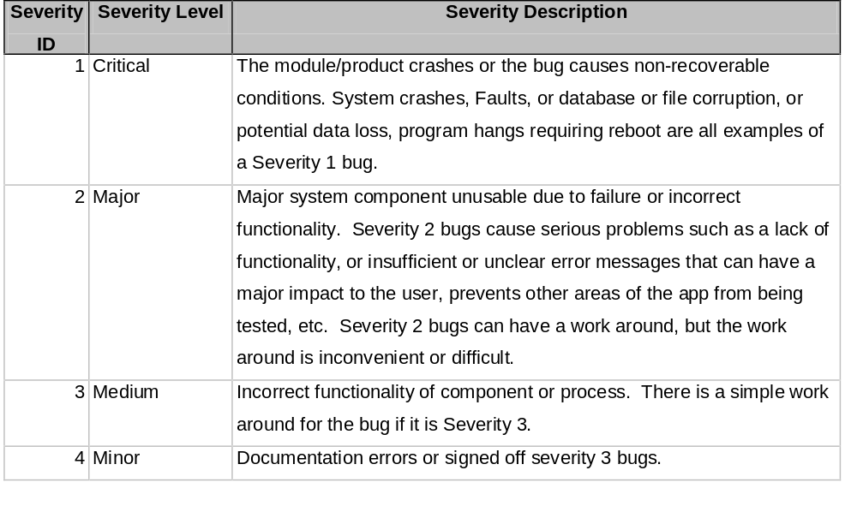

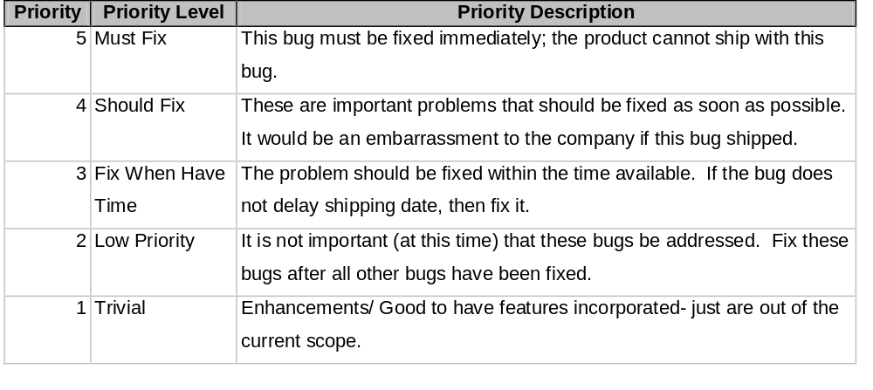

Test Result Summary

Below are summary of bugs found.
SN | Test Case | Module | No of bugs found | Status as of Jan 10
1 | Add Customer | ACS | 1 | Pending
2 | Update customer | ACS | 1 | Pending
3 | Add Dap | ACS | 1 | Pending
4 | Add Fap | ACS | 1 | Pending
5 | Add Role | ACS | 1 | Pending
6 | Add Portal Admin | ACS | 3 | 1 fixed, 2 pending
7 | Delete Portal Admin | ACS | 3 | 2 fixed, 1 pending
8 | Update Portal Admin | ACS | 3 | Fixed
9 | Add User admin/user | ACS | 1 | Pending
10 | Adding the company site | CMS | 5 | 4 fixed. 1 pending
11 | Modifying the company site | CMS | 3 | 1 fixed. 2 pending
12 | Deleting the company site | CMS | 2 | Fixed
13 | Displaying the Company Site | CMS | 2 | 1 fixed.1 pending
14 | Adding the outline | CMS | 7 | 4 fixed. 3 No fix.
15 | Modifying the outline | CMS | 0 | -
16 | Deleting the outline | CMS | 2 | Fixed
17 | Viewing the Outline | CMS | 0 | -
18 | Adding the Page | CMS | 2 | Fixed
19 | Updating the Page | CMS | 6 | Pending
20 | Viewing the Page | CMS | Not Tested Yet
21 | Deleting the Page | CMS | Not Tested Yet
22 | Manage Page | CMS | 3 | Fixed
23 | CM Portal Admin Page | CMS | 3 | Pending
24 | Add Question | MCQ | 2 | Pending
25 | Delete Question | MCQ | 1 | Pending
26 | Update Question | MCQ | 1 | Pending
27 | Exam | MCQ | 3 | Pending
28 | ExamMaintenance-Add | MCQ | 3 | Pending
29 | ExamMaintenance-Update | MCQ | 4 | Pending
30 | Section | MCQ | 3 | Pending
31 | SectionMaintenance-Add | MCQ | 5 | Pending
32 | SectionMaintenance-Update | MCQ | 4 | Pending
33 | Question | MCQ | 2 | Pending
34 | Question Maintenance | MCQ | 6 | Pending

Test Result – Bugs Detail
SN | Test Case | Module | Action | Expected Result | Actual Result | Remark | Severity | Priority | Status
1 | Add Customer | ACS | Click add button | 2. duplication check against customer ID, msg pop out if duplicated | Fail | same company created into the list | 2 | 4 | pending
2 | Update customer | ACS | Click Item to be Updated | 2. Validation check if customer update was valid msg pop out if update is invalid | Fail | $,* any symbol can be accepted in number enter erea | 2 | 4 | pending
3 | Add Dap | ACS | Click add button | 1. Duplication check against Dap, msg pop out if duplicated | Fail | Same DAP created | 2 | 4 | pending
4 | Add Fap | ACS | Click add button | 1. Duplication check against Dap, msg pop out if duplicated | Fail | Same FAP created | 2 | 4 | pending
5 | Add Role | ACS | Click add button | 1. Duplication check against Role to add, msg pop out if duplicated | Fail | Same Role created | 2 | 4 | pending
6 | Add Portal Admin | ACS | Click add button | 1. Duplication check against Portal Admin, msg pop out if duplicated | Fail | No response | 1 | 5 | Fixed
7 |  |  |  | 2.Validation check: if no User ID create, and msg pop out to inform the filling up | Fail | No response | 1 | 5 | pending
8 |  |  |  | 3. Show the sucessful msg with updated Portal Admin list | Fail | No response | 1 | 5 | pending
9 | Delete Portal Admin | ACS | Click delete button | 1. validation check if user was selected, msg pop out if no selection | Fail | No radio button for selection of item to be deleted | 1 | 5 | Fixed
10 |  |  |  | 2. Show the msg with sucessful delection | Fail | Server Error in '/' Application | 1 | 5 | pending
11 |  |  |  | 3. Show the successul msg with updated Portal Admin list | Fail | Server Error in '/' Application | 1 | 5 | pending
12 | Update Portal Admin | ACS | Click Item to be Updated | 1.Display Portal Admin info | Fail | Server Error in '/' Application | 1 | 5 | Fixed
13 |  |  |  | 2. validation check if user was selected, msg pop out if no selection | Fail | Server Error in '/' Application | 1 | 5 | Fixed
14 |  |  |  | 3. Show the successul msg with updated Portal Admin list | Fail | Server Error in '/' Application | 1 | 5 | Fixed
15 | Add User admin/user | ACS | Click add button | 1. Duplication check against User Admin/User ID to add, msg pop out if duplicated | Fail | Same User admin/user created | 2 | 4 | pending
16 | Adding the company site | CMS | Click add button | 2. Duplication of company site check required. | Fail | Message shown as "Record Not Updated ". But the site is created with same name | 2 | 4 | Fixed
17 |  |  |  | 3. If any mandatory field is missing then system should not allow to create the site. | Fail | Mandatory field marker required with "*". | 4 | 2 | Fixed
18 |  |  |  | 4. Functions provided like "Add" button to add the site. And adding the details should have "Save", "Clear" and "Cancel" Buttons | Fail | Message shown as "Record Updated Successfully " | 4 | 2 | Fixed
19 |  |  |  | 13. There has to be frame across different screens. | Fail | Add page doesn't have frame but Maintenance screen which lists the sites are having the frame. | 4 | 2 | pending
20 |  |  |  | 14. Screen top hyper links to other areas of the application should be displayed in order to make the consistency | Fail | There is no top view is being appeared comparatively with other modules. | 4 | 2 | Fixed
21 | Modifying the company site | CMS | Click Update Site Hyper Link | 4. Upon updating the site information "Site has been updated successfully" will be displayed. | Fail | Generic message shown as "Record Updated Successfully " | 4 | 2 | Fixed
22 |  |  |  | 8. Frame has to be there while updating the site information. | Fail | Update page doesn't have frame but Maintenance screen which lists the sites is having the frame. | 4 | 2 | Pending
23 |  |  |  | 10. There should not be any additional detail to be displayed. | Fail | There are 2 rows are being displayed at the top and end of the maintenance screen. | 4 | 2 | Pending
24 | Deleting the company site | CMS | Click Deletion Button | 7. Deletion of the site should be performed only one site. | Fail | Radio button is allowed to select all the sites. If this is not the case the change the radio button to tick box. | 3 | 4 | Fixed
25 |  |  |  | 8. Upon deleting one site, the maintenance screen allows to select only one site for further operation. | Fail | Screen allows to select multiple sites upon deleting the singe site. | 3 | 4 | Fixed
26 | Displaying the Company Site | CMS | Company Site Maintenance | 1. Add multiple sites then the maintenance screen keeps 10 sites listing per page. When click the second page no. the second page sites only should be displayed | Fail | Still showing the first page listing | 3 | 4 | Fixed
27 |  |  |  | 3.Page no should be displayed either at the top of the listing or bottom of the listing | Fail | Currently it shows at top as well as bottom. | 3 | 2 | Pending
28 | Adding the outline | CMS | Click Add Outline Button | 1. To navigate to Manage Outline without clicking existing site. Message should shown to select the site. | Fail | Screen refreshing the site without displaying message to select the site. | 3 | 2 | Fixed
29 |  |  |  | 4. Mandatory field validation is required while creating the outline. | Fail | Working as per the expected result  Required to indicate the mandatory field | 3 | 4 | Fixed
30 |  |  |  | 8. After the successful save the message should be shown "Outline Saved Successfully" | Fail | Message shown as "Record Updated Successfully " | 3 | 4 | Fixed
31 |  |  |  | 10. Create the outline with some special characters validation error message should thrown to show enter outline with valid characters. | Fail | Outline Name accepts with special character. | 4 | 4 | No Fix
32 |  |  |  | 14. Upon creation of the site when the outline is being created for the selected site then screen should show the site which is already selected. This is to ensure adding the outline for the correct site. | Fail | Currently there is no such information is being displayed. | 4 | 4 | No Fix
33 |  |  |  | 16. When click the next page in the outline then screen should show next page list. | Fail | Screen refreshing the same page. | 3 | 4 | Fixed
34 |  |  |  | 17. After creating the site click on the manage outline and click on add. System should display the selected site. | Fail | There is no selected site is appearing. | 4 | 4 | No Fix
35 | Modifying the outline | CMS | Click on the Delete Button | 3. Upon deleting the outline status message will be displayed to portal admin user. System show the message as "Outline Deleted Successfully" | Fail | Record Deleted Successfully | 4 | 2 | Fixed
36 |  |  |  | 8. Click one outline which is already created then press click delete, and do the same deletion operation the outline maintenance should allow to select one outline by clicking the radio. | Fail | If multiple outlines can be deleted then change the button to tick box. | 3 | 4 | Fixed
37 | Adding the Page | CMS | Click on the Add Page | 4. Upon saving the page to particular outline then response message should be displayed to portal admin. | Fail | Page Updated Successfully | 4 | 2 | Fixed
38 |  |  |  | 7. After adding the page i.e. more than 10 pages then screen should be able navigate to next page. | Fail | Currently the screen stays in the current page. | 3 | 3 | Fixed
39 | Updating the Page | CMS | Click on Update Page | 10. Once the pages are added the click the particular page for update the screen should show the selected page name. | Fail | Currently the selected page is not showing | 3 | 3 | Pending
40 |  |  |  | 11. When the page clicked for the update. Pane name should be entered for the update. | Fail | Currently the page name is not editable. | 3 | 3 | Pending
41 |  |  |  | 12. While updating the page when the "Clear" button is pressed system should clear the entered content. | Fail | Currently screen is not clearing the content. | 3 | 3 | Pending
42 |  |  |  | 13. After click the update of particular page then without the page name click save. Then system should save the record. | Fail | Though the error message is being displayed finally system saves the page. | 2 | 4 | Pending
43 |  |  |  | 14. All the blank page name should not be appeared in the system since the page name is mandatory. | Fail | All the blank page name is being displayed. | 2 | 4 | Pending
44 |  |  |  | 15. While updating the page publish and not publish should be displayed in order to publish the page. | Fail | Currently the publish and not publish is not appearing. | 3 | 3 | Pending
45 | Manage Page | CMS | Adding the content | 1. Content should be saved & Message should be shown to portal admin | Fail | Content Saved but message is not shown | 3 | 4 | Fixed
46 |  |  |  | 3. When click the File Manager link system should allow to select the file. | Fail | Exception throws | 3 | 3 | Fixed
47 |  |  |  | 4. When the image is selected for upload, system has to select the image and to be uploaded. | Fail | There are some debug popup window is being displayed. | 3 | 3 | Fixed
48 | CM Portal Admin Page | CMS | Click on Module Manager | Module Maintenance screen should displayed | Fail | Some static is being displayed. | 3 | 4 | Pending
49 |  |  |  | It should show only the module management other part of the application should not be displayed | Fail | Manage question is being displayed | 3 | 4 | Pending
50 |  |  | Click on the portal admin creation | There is no password is being displayed to create the portal admin. | Fail | Password should be asked to save | 2 | 4 | Pending
51 | Add Exam | MCQ | eg exam name > ~50 varchars will crash the system, other variables act the same | Should accept the length of all fields as defined in UCRR | Fail | Length should be checked and truncated or controlled in method if more than defined in UCRR. This is global. Only recorded as 1. | 2 | 2 | Pending
52 | Add Question | MCQ | The module name is hardcoded | Should not hardcode the subject title | Fail |  | 4 | 4 | Pending
53 |  |  | After adding question details and save. Cancel and select question to modify, the answer is not displaying correctly. The small window does not display the list of option answers.(this is not exclusive. Sometimes will display the question options correct, sometimes just display empty window. | Should display the records correctly | Fail |  | 2 | 2 | Pending
54 |  |  | Select section Exam->Manage Section->Manage Question for adding new questions into the section | Should go to Question Pool Manager screen | Fail | Throw exception. All interfaces have this issue. Recorded as 1. | 2 | 2 | Pending
55 |  |  | Key in Exam Level,question text,Question Type ,Exam Type ,Choices:,is Answer? ,Option Text | Question should be saved | Fail | Throw exception | 2 | 2 | Pending
56 | Update Question | MCQ | Select Exam->Manage Section->Manage Question, select a question | 1. Display the question details | Fail | Throw exception | 2 | 2 | Pending
 |  |  | Modify question details | 2. Validate it is updated
57 | Delete Question | MCQ | Select question name/s | The question/s should remove from the list | Fail | Throw exception | 2 | 2 | Pending
 |  |  | Click delete button
58 |  |  | Exception error when select Exam or Survey->click Question Pool Manager->click Cancel button->will go to Add Question screen->click Cancel button->will go to Question screen-> exception error. | Should handle the multiple clicking properly | Fail | Throw exception | 2 | 2 | Pending
59 | Interface - Exam | MCQ | Question Pool Manager | Should go to Question Pool Manager screen | Fail | Doesn't seem right. Attached the screen captured. | 2 | 2 | Pending
60 |  |  | Section manager | Should go to Section Manager screen | Fail | Exeption error. Attached screen captured. | 2 | 2 | Pending
61 | Interface - ExamMaintenance | MCQ | Reports | Should go to Reports screen | Fail | Not working. Nothing happen. | 4 | 4 | Pending
62 |  |  | Question Pool Manager | Should go to Question Pool Manager screen | Fail | Doesn't seem right. Attached the screen captured. | 4 | 4 | Pending
63 |  |  | Section manager | Should go to Section Manager screen | Fail | Exeption error. Attached screen captured. | 2 | 2 | Pending
64 | Interface - ExamMaintenance | MCQ | Clear | Should clear the selection | Fail | Failed. Can see some processes running but at the end nothing change on screen. | 2 | 2 | Pending
65 |  |  | Reports | Should go to Reports screen | Fail | Not working. Nothing happen. | 4 | 4 | Pending
66 |  |  | Question Pool Manager | Should go to Question Pool Manager screen | Fail | Doesn't seem right. Attached the screen captured. | 2 | 2 | Pending
67 |  |  | Section manager | Should go to Section Manager screen | Fail | Exeption error. Attached screen captured. | 2 | 2 | Pending
68 | Interface - Section | MCQ | Reports | Should go to Reports screen | Fail | Not working. Nothing happen. | 4 | 4 | Pending
69 |  |  | Question Pool Manager | Should go to Question Pool Manager screen | Fail | Doesn't seem right. Attached the screen captured. | 2 | 2 | Pending
70 |  |  | Section manager | Should go to Section Manager screen | Fail | Exeption error. Attached screen captured. | 2 | 2 | Pending
71 | Interface - SectionMaintenance | MCQ | Clear | Should clear the screen or changes or details | Fail | Failed. It goes back to previous screen. | 2 | 2 | Pending
72 |  |  | Reports | Should go to Reports screen | Fail | Not working. Nothing happen. | 4 | 4 | Pending
73 |  |  | Question Pool Manager | Should go to Question Pool Manager screen | Fail | Doesn't seem right. Attached the screen captured. | 2 | 2 | Pending
74 |  |  | Section manager | Should go to Section Manager screen | Fail | Exeption error. Attached screen captured. | 2 | 2 | Pending
75 | Interface - Question | MCQ | Add | Should add new question | Fail | Failed to add. Exception error. Attached the screen captured. | 2 | 2 | Pending
76 |  |  | Option Text Add | Should add an new option | Fail | 1st time add will delete an option. Subsequent adding is OK. | 2 | 2 | Pending
77 |  |  | Option Text Delete | Should remove an option | Fail | Failed to remove. Nothing happen. | 2 | 2 | Pending
78 |  |  | Reports | Should go to Reports screen | Fail | Not working. Nothing happen. | 4 | 4 | Pending
79 |  |  | Question Pool Manager | Should go to Question Pool Manager screen | Fail | Doesn't seem right. Attached the screen captured. | 2 | 2 | Pending
80 |  |  | Section manager | Should go to Section Manager screen | Fail | Exeption error. Attached screen captured. | 2 | 2 | Pending

Conclusion:

Overall, from individual unit test, we have found bugs with its categorization as below:

 | Module | Critical | Major | Medium | Minor
1 | ACS | 9 | 6 | 0 | 0
2 | CMS | 0 | 4 | 19 | 12
3 | MCQ | 0 | 23 | 0 | 7

All bugs will be resolved by Jan 2010 before hand the application over to user for User Acceptance Test.

Approval Record DOCS/Forms/Approval
Project Name Content Management Portal
Document Ref CMP/DOCS/TC.3/1
Approved by Haiyang | Date
Authorised by | Date
The document authorisation appears on the title page. |  | ✔
The structure of the document is logical. |  | ✔
The distribution list is correct. |  | ✔
The title page is signed |  | ✔
Calculations appear reasonable, are neatly presented and have been checked. |  | ✔
Theory and formulae are correct and properly applied. |  | ✔
Illustrations are relevant, readable and logically placed. |  | ✔
There are no typographical errors. |  | ✔
Units are consistent throughout. |  | ✔
The security classification is correct. |  | ✔
There are no obvious omissions. |  | ✔
The document complies with the Client's requirements, however specified. |  | ✔
Responsibility is accepted for all opinions, conclusions and recommendations. |  | ✔
The document does not run counter to company policy. |  | ✔

